## – Make feedback box bigger

The feedback box fills the column’s width.

## 1.3, 1.5 - Configuration page

* **Moodle url path:** The url input texts have been split up into 2 sections. Host name and the according webpage/api call. There is only one input text to determine the moodle host name url. No need to type it 3 times. There are 3 inputs to type in the webpage/api call. All these fields will be populated by default but the user must click the ‘Verify’ button and save.
* **Barcode:** The ‘barcode’ checkbox is not mandatory any more.

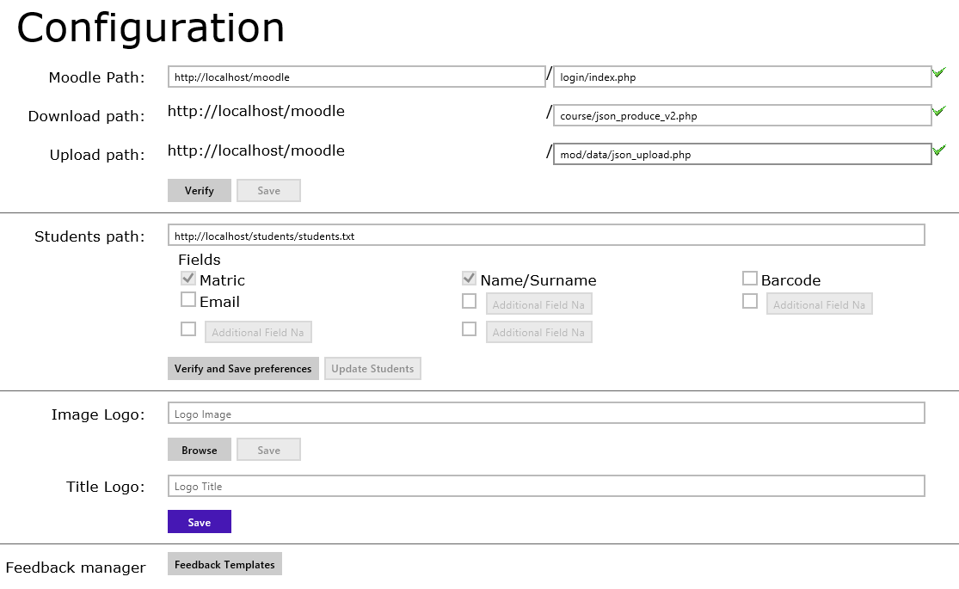

## 1.4 – Remove the ‘Marks/20’ display from the DOPs forms

Please verify that the template in Moodle website does not contain a 'TotalMark' text field. Any form that has this 'TotalMark' text fields it will display a total of the score within the form.

Fixed the user interface on the yellow preview tab.

## 1.6 – App version on navigation bar

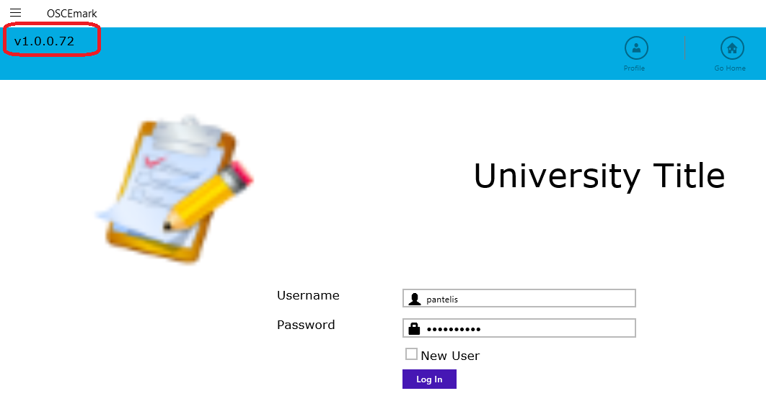

## 1.7 – Fix ordering on ‘Downloaded forms’ and ‘forms’

* Fixed ‘forms’ ordering and remember the filter settings when going back and forth between the forms table page and opening a form for assessment.
* Fixed ‘downloaded forms’ ordering and remember the filter settings. The user can order by ‘Course Name’ or ‘ID’ and then by ‘title’.
* Faster loading of the ‘downloaded forms’ and ‘forms’ tables.
* Faster deletion of form folder.
* Faster downloading/populating exam.

## 1.8 – Display category name and id on download forms page.

Added 2 new columns to the downloaded forms table. The user can now see the course name of each exam.

If there are already forms on the tablet (after the latest update) the user must login and 'SYNC' the table.

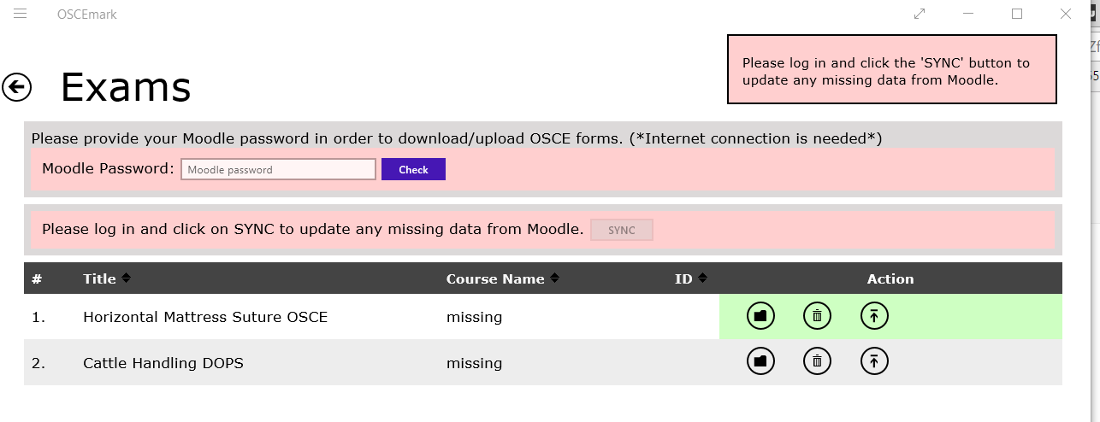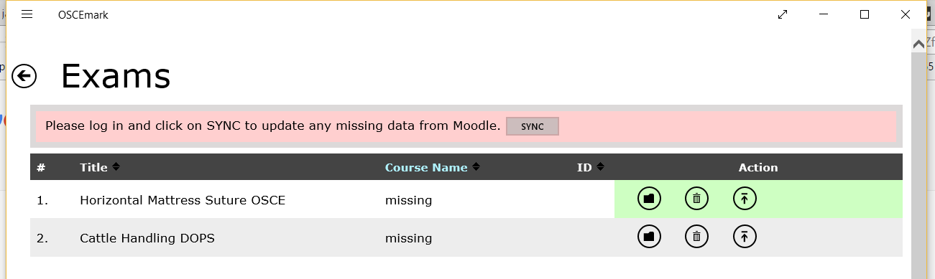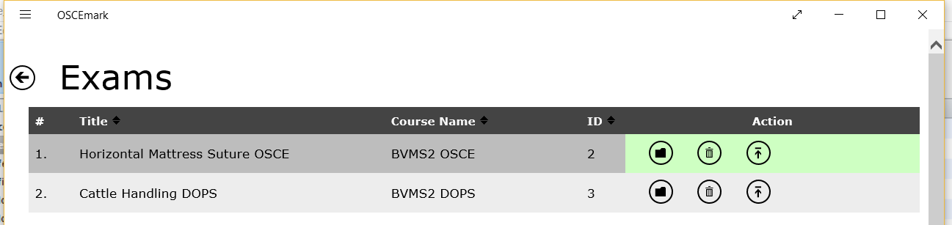

The user can order by ‘Course Name’ or ‘ID’ and then by ‘title’.

The api has changed in order to synchronise the exams’ course name and id. Also I’ve made some more alterations in order to download the forms faster.

When the time comes to test the new version of the app you must remember to paste the new ‘json_produce.php’ file to the server. The name of the updated file is ‘json_produce_v2.php’. Please make sure to set the correct path in the configuration before start testing.